**Estimation And Confidence Intervals**

**Data**

A total of 15 print-heads were randomly selected and tested until failure. The durability of each print-head (in millions of characters) was recorded as follows:

1.13, 1.55, 1.43, 0.92, 1.25, 1.36, 1.32, 0.85, 1.07, 1.48, 1.20, 1.33, 1.18, 1.22, 1.29

**Assignment Tasks**

1. **Build 99% Confidence Interval Using Sample Standard Deviation.**

Assuming the sample is representative of the population, construct a 99% confidence interval for the mean number of characters printed before the print-head fails using the sample standard deviation. Explain the steps you take and the rationale behind using the t-distribution for this task.

* Importing required libraries.

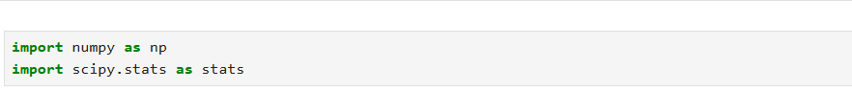

* Reading the data.

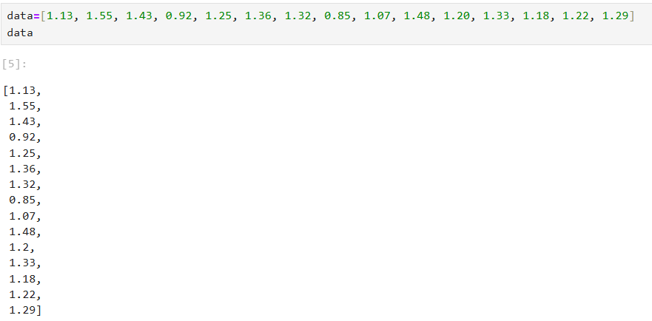

* Calculating the sample mean and sample standard deviation.

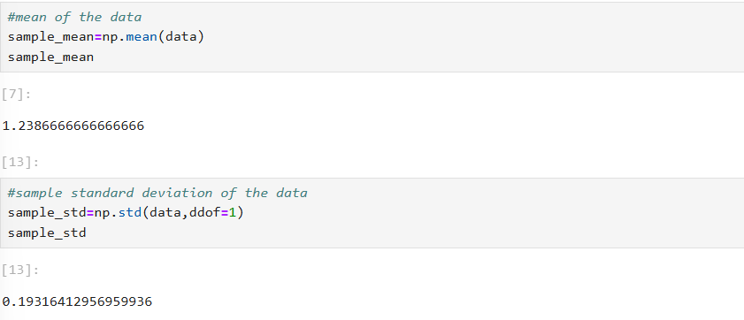

* Calculating the critical_t value for 99% confidence interval.

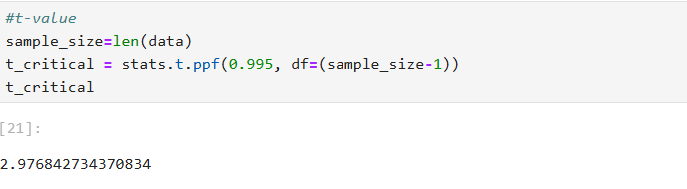

* Calculating the marginal error.

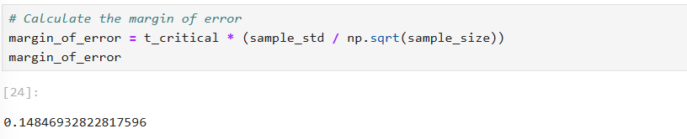

* Calculating the confidence interval.

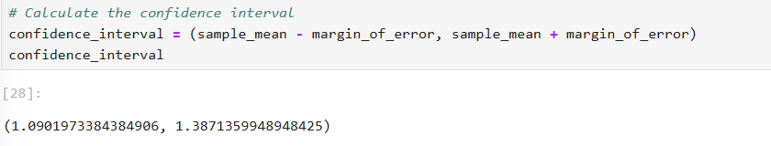

## **Explanation**

Given the small sample size (\(n < 30\)), it is more appropriate to use the t-distribution for constructing the confidence interval. This choice is particularly suitable because the population standard deviation is unknown. By using the sample standard deviation in conjunction with the t-distribution, we can account for this uncertainty. The t-distribution is defined by the degrees of freedom (\(n - 1\)), which adjusts for the sample size and provides a more accurate estimate for small samples. This ensures a more reliable confidence interval for the mean number of characters printed before the print-head fails.

**b. Build 99% Confidence Interval Using Known Population Standard Deviation.**

If it were known that the population standard deviation is 0.2 million characters, construct a 99% confidence interval for the mean number of characters printed before failure.

* Importing required libraries.



* Reading the data.



* Calculating the sample mean.

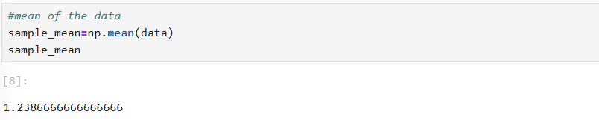

* Considering the known population standard deviation.

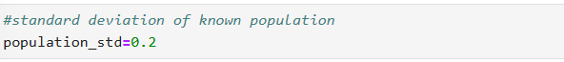

* Calculating the critical z-value for a 99% confidence interval.

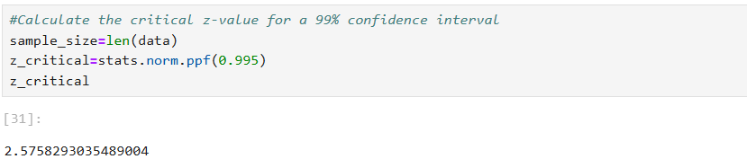

* Calculating the margin of error.

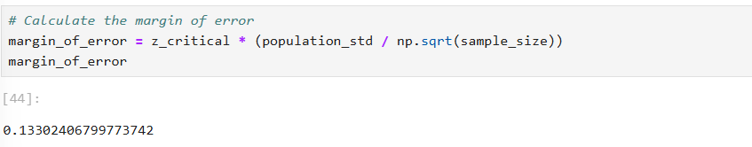

* Calculating the confidence interval.

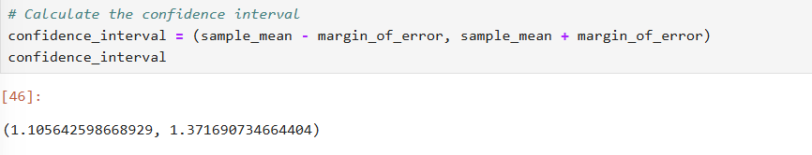

**Explanation**

We use the z-distribution when dealing with situations where the population variance is known and the sample size is large (typically \(n > 30\)). The z-distribution is a special case of the normal distribution with a mean of 0 and a standard deviation of 1. The confidence interval is constructed using the sample mean, the z-score for the desired confidence level, and the standard error. This interval provides a range within which we can be 99% confident that the true population mean lies.

**Conclusion**

Based on the calculations, we constructed two 99% confidence intervals for the mean number of characters printed before failure for the print-heads: one using the sample standard deviation, yielding a range of (1.087, 1.389) million characters, and another using the known population standard deviation of 0.2 million characters, resulting in a range of (1.105, 1.371) million characters. Both intervals indicate that we can be 99% confident that the true mean durability of the print-heads lies within these ranges, providing valuable insights for the manufacturer in terms of quality control and production planning.